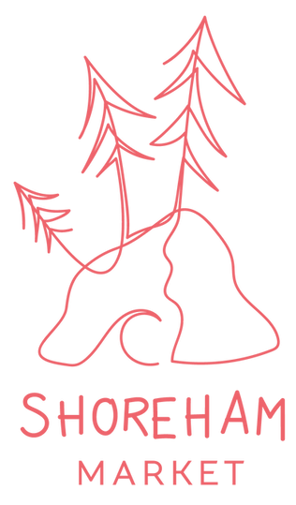

Stallholders Application Form

2022/23 Spring & Summer Dates:
Oct 16, Nov 20, Dec 18, Jan 15, Feb 19, Mar 19, April 16, May 21 - 3rd Sunday of the month

Time: 10am - 2pm

Location: Shoreham Common, Shoreham, VIC, 3916
Corner of Byrnes and Cliff rd, beside the tennis court.

Stall catagrogy & price (per market):
- Produce & Local Business (incl baked goods & drinks) - $105
- Hot Food - $180
- Second Hand/Thrift - $70
- Community / Education - $20

Notes
- All stalls are 3x3 meters unless otherwise discussed.
- It is each stall holder's responsibility to bring their own stall set up.
- We aim to be a zero-waste market, if you do have any rubbish we ask that you manage and dispose of it yourself.
- There isn't an ATM in the area, so stallholders will need to come prepared

Please fill out the table below & email this document back to us at shorehammarket@gmail.com

Business name
Your product or service
Date(s) are you applying for
Stall category
Specific site requirements
(Size, Power, Shade…)

Do you need a car, van, truck, trailer space?
If food, do you have a food stall License?
Do you have Public Liability Insurance?
Are you selling alcohol?
Note. We do not have a liquor license and no liquor will be allowed to be opened on the market grounds.

